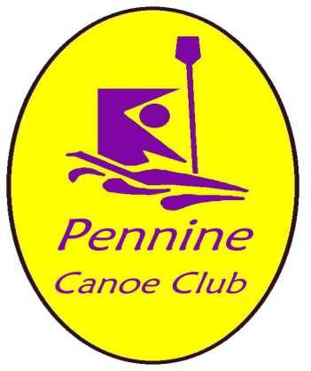
Development of the Mirfield site and expansion of the Club – update May 2013
Plans for the development of the new site for the club in Mirfield are progressing well. We have established a small group, with the local rowers, to take forward the actions set out below so that we can be on the water this summer.
- Formation of company limited by guarantee (with Rowers) to support grant applications
- Expansion of club to include Rowing
- Signing of lease with James Walker for permission to use the land
- Obtaining Planning and Environment agency permissions
- Initial funding / grants
- Access to the site and building of jetty / river access
We held a very successful promotional event on Saturday 4th May at the South Pennine Boat Club in Mirfield with our paddlers giving demos on the water. There were many visitors including local organisations who pledged their support and we collected names of anyone interested in joining us.
We have created a logo below which follows our original club colour scheme, which we plan to use for any joint activities. The Pennine Canoe Club logo will still be used for our canoeing activities.
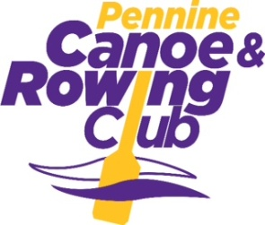
This is an exciting development for the club and we welcome any support and will keep you updated as our plans progress.
Additional information to support the development of the Mirfield site and expansion of the club
- Organisation Structure

- Pennine Watersports limited
A company limited by Guarantee will be set up to support funding and grant applications. There will be three Directors /Trustees from both the Canoeing and Rowing memberships.

Canoe Club nominees are:
- David Gent (Pennine Canoe Club President)
- David Jefferies (Pennine Canoe Club Chairman)
- Andrew Carden (Pennine Canoe Club Vice-Chairman)

- Pennine Canoe and Rowing Club
A joint Group will be set up to represent all users of the Mirfield site and provide channels of communication to ensure equitable and fair practices and procedures for all. Membership of the User Group will include an equal number of Canoeing and Rowing members. Invitations will also be made to representatives from organisations providing support, including James Walker (landowner), Kirklees Council / Leisure Services and others.
- Pennine Canoe Club
The Pennine Canoe Club will continue to operate with the same organisation structure and use the existing logos for publicity and team kits. Initially some of the Rowers will join the Canoe Club to enable joint activities to take place.
- Pennine Rowing Club
At the appropriate time a new Rowing club will be established which will also have an individual logo and branding to promote specific rowing activities.
- Funding
Grants are expected from Kirklees Council, initially for a minimum of £500 and we will seek additional grants and funding. The Rowing Club members have pledged to make a contribution of £750 through a loan. We are looking for a contribution from the Canoe Club through general available funds. Additional opportunities will be available to all members of both clubs through a ‘Sponsor a Brick campaign’, where donations are made and names of the donor will appear in the new Club facility. Initially funds will be needed to cover:
- External Legal fees to draw up and agree the lease for use of the land at James Walker’s site (estimated c£1,000)
- Groundworks to provide access & gate, clear the site and build a concrete jetty /river access (minimum c£2,000)
- Planning consent (costs to be agreed)

